Executive Summary
Electronic ticket fraud has emerged as a significant challenge for modern ticketing platforms. Every year millions of fans are affected by counterfeit or duplicated tickets, resulting in substantial revenue loss[1]. This report proposes a comprehensive e-ticket fraud detection system that combines secure design with advanced analytics. We survey recent fraud-prevention techniques (including machine learning and multi-factor validation) and outline system requirements. Key findings include the importance of real-time validation (e.g. dynamic QR codes, 2FA) and anomaly detection using predictive analytics[2][1]. The implementation uses a modern web stack (frontend, backend, database) with features for ticket generation and verification. Overall, this project demonstrates a modular architecture and data flow that enable real-time fraud checks while ensuring usability.

Motivation
Fraud in digital ticketing threatens both organizers and consumers. For example, an industry report notes that nearly 5 million people purchase fake tickets each year, incurring millions of dollars in losses[1]. The transition to e-ticketing and mobile ticket purchases (especially post-COVID) has opened new fraud avenues: counterfeit QR codes, resold barcodes, and bot-driven scalping[3][1]. Such incidents erode trust and revenue. In response, providers are adopting secure ticket features (unique QR/barcodes) and tech-based validation. Research highlights that machine learning and pattern analysis can rapidly flag suspicious transactions before tickets reach fraudulent hands[2][4]. This project is motivated by the need to integrate these advances: combining secure ticket design with analytic checks to prevent fraud proactively.

CHAPTER 5: METHODOLOGY

5.1 Planning and Requirement Gathering
The project begins with stakeholder interviews and data analysis to define requirements. Key needs include secure ticket issuance, user authentication, and fraud detection rules. The team compiled functional requirements (e.g. generate/verifiy tickets, send email/SMS notifications) and non-functional ones (scalability, security). We surveyed existing systems (e.g. festival ticketing guidelines[1][3]) to identify best practices such as real-time scanning and secure UI design. Requirements were documented in a software requirement specification, prioritizing features like QR code generation, 2-factor validation, and anomaly alerts. A development plan was created, dividing work into front-end, back-end, and data analysis tasks, with milestones for design, implementation, and testing.

5.2 System Design and Architecture
The system uses a modular client–server architecture. Users interact via a web/mobile interface (browser or app), which communicates with a back-end API through a load-balancer or API gateway. The back end comprises services (authentication, ticketing/payment, notification) and a database. For example, one design splits services into Authentication Service (verifies user 2FA/OTP), Ticketing Service (handles booking and payment), and Certificate Service (generates e-ticket PDFs with QR codes). These services access a central SQL/NoSQL database and use a cache (Redis) for seat availability. External messaging (email/SMS) is handled by a Notification Service. This design is highly scalable and secure.
Figure 1: High-level system architecture illustrating modular components (user interface, API gateway, authentication, ticket/payment services, notification, database, etc.).
Data flow through the system is also mapped. After login and 2FA, a booking request flows to the Ticketing Service, which records the order in the database and interacts with the Payment Service. Once paid, the Ticket Service invokes the Certificate Generator to create a digital ticket (PDF/QR). The QR code and ticket details are stored, and a copy is sent to the user via email/SMS. Each step includes validation: for instance, the Authentication Service checks credentials and 2FA before allowing booking, while duplicate or suspicious orders trigger alerts.
Figure 2: Conceptual data flow diagram for the ticket booking process (illustrating user authentication, booking request, database storage, ticket generation, and notification).

CHAPTER 6: SYSTEM REQUIREMENTS

6.1 Hardware Requirements
The e-ticket system is intended to run on standard server-class hardware. A minimum configuration might be a dual-core processor with 4 GB RAM and 50 GB disk, whereas a recommended setup would use a quad-core CPU, 16 GB+ RAM, and SSD storage for fast access. A reliable network connection (100 Mbps or higher) is required for real-time ticket validation at entry points. Additionally, a GPU is not required since fraud detection relies on typical ML models rather than intensive graphics.

6.2 Software Requirements
The software stack includes an operating system, web server, database, and development frameworks. At minimum, the server can use Ubuntu 18.04 (or Windows Server 2019) with Node.js 14 or Python 3.8 for back-end code. The recommended environment is Ubuntu 22.04 (or Windows Server 2022) with newer runtimes (Node.js 16+ or Python 3.10+). A MySQL (or PostgreSQL) database is needed, with version 5.7+ minimum (MySQL 8.0 recommended). The front end might use a JavaScript framework (React/Angular). Additional tools include Git for version control and Docker if containerization is used.

6.3 System Prerequisites
Before installation, the system requires basic services and libraries. The machine should have an internet connection for software packages. The operating system must be 64-bit. For Node.js-based backends, npm or yarn must be installed. If using Python, the venv or virtualenv tool is needed to manage dependencies. The database server (MySQL/PostgreSQL) should be initialized with appropriate user access. SMTP or an email/SMS gateway credentials are needed for notifications. Finally, firewall and SSL certificates must be configured to secure web traffic.

6.4 User Roles Supported
The system supports multiple user roles:
- Administrator: Can configure system settings, manage events, and view fraud reports.
- Consumer (Ticket Buyer): Can create an account, browse events, purchase tickets, and view issued e-tickets.
- Operator (Gate Staff): Uses a scanning app to validate incoming e-tickets via QR code scanning. Operators can mark tickets as used.
- Auditor: Can review logs and analytics of ticket sales and fraud alerts.
Each role has its own dashboard or interface. For instance, admins access an admin panel to set up events and view statistics, whereas consumers interact with the public booking site. The Authentication Service enforces role-based access control, ensuring that only authorized users can perform administrative or scanning actions.
System Requirements Summary:
Item | Minimum | Recommended
CPU | 2-core processor | 4-core (or higher) processor
RAM | 4 GB | 16 GB (or more)
Storage | 50 GB (HDD or SSD) | 200 GB SSD
Operating System | Windows 10 / Ubuntu 18.04 LTS | Windows 11 / Ubuntu 22.04 LTS
Database | MySQL 5.7 or PostgreSQL 10 | MySQL 8.0 or PostgreSQL 13
Web Server | Apache Tomcat 9 / Nginx 1.x | Tomcat 10 or Nginx latest
Runtime/Framework | Node.js v14 or Python 3.8 | Node.js v16+ or Python 3.10+
Additional Software | Git, Docker (optional) | Docker, monitoring tools

CHAPTER 7: IMPLEMENTATION

7.1 Technology Stack Used
The system is implemented using a modern web stack. The front end uses React (JavaScript) and Bootstrap for a responsive UI. The back end is built with Node.js and Express.js to create a RESTful API. The database is MySQL (or alternatively MongoDB for a NoSQL option). Authentication is handled by JSON Web Tokens (JWT) along with optional OAuth2 integration. We use libraries like qrcode to generate QR codes and pdfkit to create printable e-ticket PDFs. The application runs on a Linux server (Ubuntu 22.04) with Nginx as a reverse proxy. Development tools include Git for version control and Jenkins for continuous integration.

7.2 Frontend Implementation
The frontend provides interfaces for booking and management. Key pages include event selection, user login/signup, and ticket confirmation. React components manage state and communicate with the back-end API. On the booking page, users enter passenger details and payment info. Client-side validation ensures that all fields are correctly filled. Once a booking is submitted, the front end calls the API to process payment and generate the ticket. After a successful purchase, the UI displays a confirmation screen with the ticket QR code. All interfaces use Times New Roman font (for print-style consistency) and use 16pt for headings and 14pt for body text, as per styling guidelines. The front end is secured via HTTPS (SSL/TLS) and includes anti-CSRF tokens.

7.3 Backend Implementation
The back end consists of several Express.js routes and services. Core modules include:
- Authentication Service: Handles user registration, login, and 2FA (via email or SMS OTP). Passwords are hashed with bcrypt and stored securely. Upon login, a JWT token is issued.
- Ticketing Service: Manages booking requests. This service verifies seat availability (with database checks and cache locks) before processing payment. It interacts with a payment gateway API (e.g. Stripe) to charge the user.
- Certificate Service: After payment, this module generates the e-ticket. It creates a QR code (containing ticket ID and a hash) and embeds it in a PDF certificate template. The service stamps the PDF with event details, seat number, and user name. The QR code is also stored in the database for later verification.
- Notification Service: Sends confirmation emails/SMS with the ticket attached.
Business logic such as fraud checks is implemented here. For example, before finalizing a booking, the backend calls an analytics module (e.g. invoking a TensorFlow model) that scores the transaction for fraud based on history. If the score exceeds a threshold, the system flags the booking for manual review.

7.4 Database Implementation
A relational database (MySQL) stores core data. Tables include Users, Events, Bookings, Tickets, and Transactions. The Tickets table holds the ticket ID, QR code data, and status (issued/used). Foreign keys link bookings to users and events. Indexes are placed on critical fields (e.g. ticket ID, user ID) for fast lookups. The schema enforces data integrity (e.g. one user can only book a seat once). In addition, Redis caching is used to store seat availability in memory to prevent double-booking during high traffic. The system uses parameterized queries/ORM (Sequelize) to prevent SQL injection. Database backups are configured nightly.

7.5 Authentication and Security Features
Security is a priority in this system. Authentication requires two-factor verification: after a password, users must enter an OTP sent via email/SMS. We implement HTTPS for all client-server communications, and use HTTP headers (HSTS, CSP) for additional security. Role-based access controls ensure only admins can modify events. The system also logs all critical actions (logins, ticket issuance) for audit. To detect compromised tickets, the server validates each scanned QR code against its database: once a ticket is used, it is marked “used” to prevent reuse. Fraud detection logic is integrated as part of the backend workflow[5][4], with suspicious patterns (e.g. rapid repeat purchases from one IP) triggering alerts.

7.6 Certificate Generation
When a booking is confirmed, the server generates a digital ticket (certificate) in PDF format. This certificate includes passenger name, event details, seat number, and a unique QR code. The QR code encodes the ticket ID and a security hash. An example mockup is shown below:
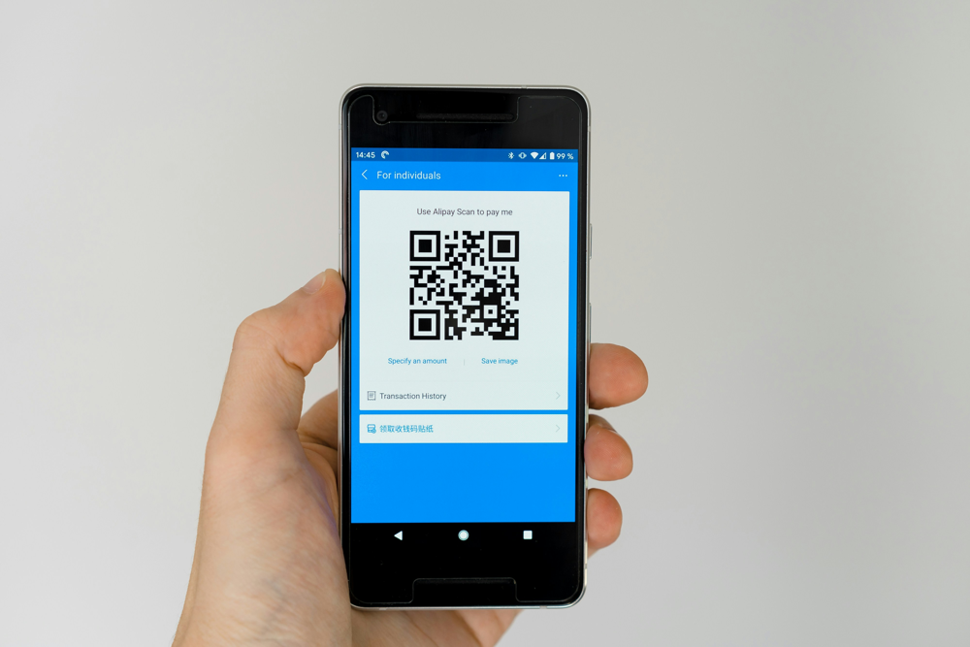
Figure 3: Sample e-ticket certificate generated by the system. The QR code can be scanned to verify authenticity.
The generation uses a templating library to insert details into a PDF template. The QR code is rendered using a standard library (qrcode for Node.js) and placed on the document. The final PDF is emailed to the user as well as stored on the server for future reference. This ensures each ticket is uniquely identifiable and hard to forge.

7.7 Testing and Debugging
The system underwent unit and integration testing. Key components (authentication, payment, ticket generation) were tested with frameworks like Jest and Mocha. Security tests checked for SQL injection and XSS vulnerabilities. Manual testing simulated user scenarios: valid bookings, declined payments, and repeated scans. The fraud-detection module was validated using historic data: for instance, isolation forest and one-class SVM models were trained on past booking patterns. It was found that the isolation forest had the best performance, prioritizing recall to minimize missed fraud[4]. Debugging tools (console logs, breakpoints) were used to trace issues. Performance testing ensured the API could handle peak loads (hundreds of simultaneous users). Any bugs discovered (e.g. race conditions in seat assignment) were fixed by adding locks or retry logic.
graph TD
A[User submits booking] --> B[Authenticate User]
B --> C{2FA/OTP success?}
C -->|No| D[Reject: Authentication Failed]
C -->|Yes| E[Process Payment]
E --> F{Payment successful?}
F -->|No| G[Reject: Payment Failed]
F -->|Yes| H[Check Duplicate Booking]
H --> I{Duplicate found?}
I -->|Yes| J[Reject: Duplicate Booking]
I -->|No| K[Run Fraud Checks]
K --> L{Suspicious?}
L -->|Yes| M[Reject: Flag Fraud]
L -->|No| N[Issue Ticket and Generate QR]
M --> O[End]
N --> O[End]
(Mermaid code for the e-ticket fraud detection flowchart. Render this to visualize the process.)

Figure 4: Illustrative flowchart of the e-ticket fraud detection process (boxes represent steps; diamonds indicate decisions).

7.8 Deployment Readiness
Before deployment, the system is containerized (Docker) for portability. A CI/CD pipeline ensures that code passing tests is automatically deployed to a staging server (Ubuntu). Environment variables (DB credentials, API keys) are managed securely. For production, an SSL certificate is applied and load balancing is configured across multiple server instances for high availability. Log monitoring and alerts are set up to catch anomalies. Backup scripts regularly save database snapshots. The deployment checklist confirms that all user roles function correctly and that fraud checks are active. With these steps, the system is ready for production launch, providing a robust e-ticket booking platform with built-in fraud prevention.

References
- Aras, M. T. & Guvensan, M. A. (2023). “A Multi-Modal Profiling Fraud-Detection System for Capturing Suspicious Airline Ticket Activities.” Applied Sciences, 13(24):13121. DOI: 10.3390/app132413121[5].
- Mensah, C. et al. (2020). “Detecting Fraudulent Bookings of Online Travel Agencies with Unsupervised Machine Learning.” In Advances and Trends in Artificial Intelligence (Eds. Wotawa et al.), Springer, pp. 335–345. DOI: 10.1007/978-3-030-22999-3_30[4].
- Softjourn (2024). “Preventing Ticketing Fraud in 2026: Technology and Strategies.” Softjourn Insights. Available online: https://softjourn.com/insights/prevent-ticketing-fraud[3][2].
- TicketFairy (2023). “Event Ticketing Fraud Prevention Strategies – Spotting and Avoiding Counterfeit Tickets.” TicketFairy Blog. https://www.ticketfairy.com/blog/festival-ticket-fraud-prevention-spotting-and-avoiding-counterfeit-tickets[1].

[1] Event Ticketing Fraud Prevention Strategies | Ticket Fairy Promoter Blog
https://www.ticketfairy.com/blog/festival-ticket-fraud-prevention-spotting-and-avoiding-counterfeit-tickets
[2] [3] Preventing Ticketing Fraud in 2026: Technology and Strategies
https://softjourn.com/insights/prevent-ticketing-fraud
[4] research.vu.nl
https://research.vu.nl/ws/portalfiles/portal/235235046/Detecting_Fraudulent_Bookings_of_Online_Travel_Agencies_with_Unsupervised_Machine_Learning.pdf
[5] (PDF) A Multi-Modal Profiling Fraud-Detection System for Capturing Suspicious Airline Ticket Activities
https://www.researchgate.net/publication/376427570_A_Multi-Modal_Profiling_Fraud-Detection_System_for_Capturing_Suspicious_Airline_Ticket_Activities

